Appsters Industry Page Layout
TAXI
Laid out fold by fold against www.appsters.io/industry
 | DETAIL
Slug | taxi-app-development-company
Meta Title | Taxi App Development Company | Ride Hailing Apps Like Uber
Meta Description | Launch a ride booking app with fast driver matching, live GPS and fair pricing. Appsters builds taxi and fleet platforms. Get your quote in 24 hours.
Layout Source | www.appsters.io/industry
Live Folds | 23
New Blocks Required | 3
FOLD 1: Hero Banner
Hero Banner
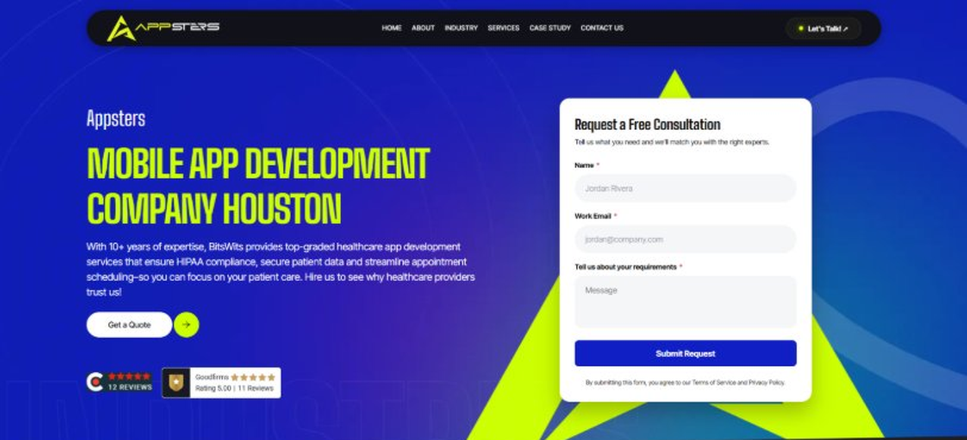
Current live page, www.appsters.io/industry
 | DETAIL
Status | New copy applied
Build Notes | Live block holds H1, sub copy, a Get a Quote button and the Request a Free Consultation form. New copy supplies the H1 and sub copy only.
QA Flag | Live hero copy currently names BitsWits and describes healthcare services. Leftover copy from another build, replace it with the new copy below.
Copy For This Fold
PAGE ELEMENT | COPY (WORD FOR WORD)
H1 (Page Heading) | A Taxi App Development Company Building Platforms That Get Riders There On Time
Body Copy | Riders decide whether they trust an app within the first failed pickup. As a taxi app development company, Appsters builds platforms that match riders with drivers fast, price rides fairly, and keep both sides informed from request to drop-off. We work as a ride booking app development company for startups and established fleets who need software that competes with the biggest names in the space.
FOLD 2: Marquee Strip
Marquee Strip: Turn Your Wildest Ideas Into Powerful Digital Products
Current live page, www.appsters.io/industry
 | DETAIL
Status | No copy change
Build Notes | No new copy in the source document for this fold. Keep the live block exactly as it is.
FOLD 3: Stats Counter
Stats Counter: Work With A Local Mobile App Developer In Houston
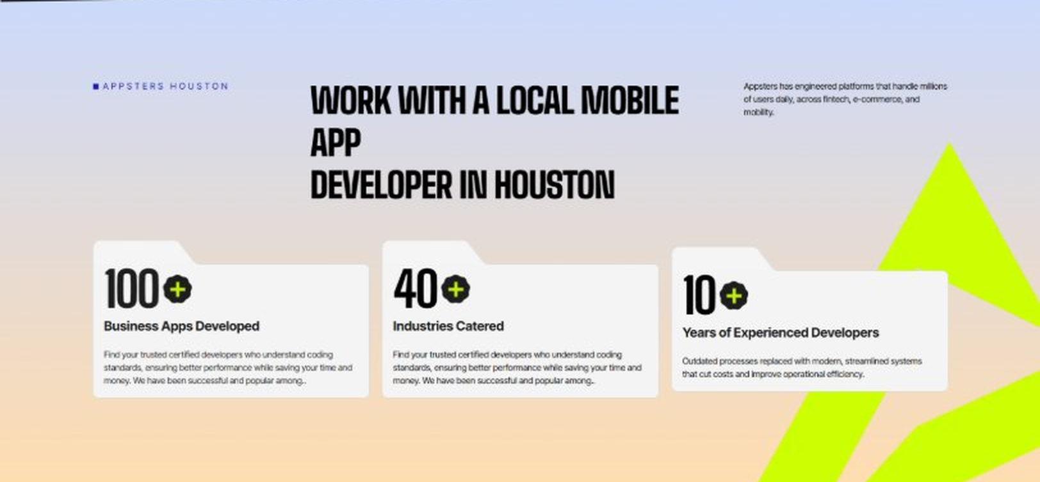
Current live page, www.appsters.io/industry
 | DETAIL
Status | New copy applied
Build Notes | Live block holds 3 counters. New copy holds 6 stats. Either widen the block to 6 or drop two.
Copy For This Fold
PAGE ELEMENT | COPY (WORD FOR WORD)
H2 (Section Heading) | Awarded For Building Taxi Apps That Keep Riders And Drivers On Time
Body Copy | Our ride-hailing app development work has earned recognition for match speed, GPS accuracy, and measurable driver retention gains. Appsters has been recognized for delivering platforms that route drivers efficiently, price fairly, and stay reliable during rush hour and surge demand. Every award reflects tested performance, not a pitch deck.
Stat 1 Number | 40+
Stat 1 Label | Industries Served
Stat 1 Copy | Our experience spans social platforms, marketplaces, fintech, healthcare, and more, with solutions adapted to each sector's demands for security, AI, compliance, and user adoption.
Stat 2 Number | 3000+
Stat 2 Label | Apps and Solutions Delivered
Stat 2 Copy | Thousands of projects executed with an emphasis on speed, AI adoption, stability, and clear ROI across both startup and enterprise environments.
Stat 3 Number | 60+
Stat 3 Label | AI Models Deployed
Stat 3 Copy | Every model is designed for high accuracy, reliable outputs, and performance at scale for mission-critical workflows and more.
Stat 4 Number | 50,000+
Stat 4 Label | Legacy Processes Modernized
Stat 4 Copy | Outdated processes replaced with modern, streamlined systems that cut costs and improve operational efficiency.
Stat 5 Number | 250+
Stat 5 Label | Engineers and Designers
Stat 5 Copy | A global team skilled in native mobile app development, AI-driven ecosystems, cross-platform builds, and enterprise architecture.
Stat 6 Number | 95%
Stat 6 Label | Client Retention
Stat 6 Copy | Long-term partnerships built on trust, consistent delivery, and continuous optimization of live applications.
FOLD 4: Marquee Strip
Marquee Strip: Mobile App Development Services
Current live page, www.appsters.io/industry
 | DETAIL
Status | No copy change
Build Notes | No new copy in the source document for this fold. Keep the live block exactly as it is.
FOLD 5: Services Grid
Services Grid: Our Comprehensive Mobile App Development Services In Houston
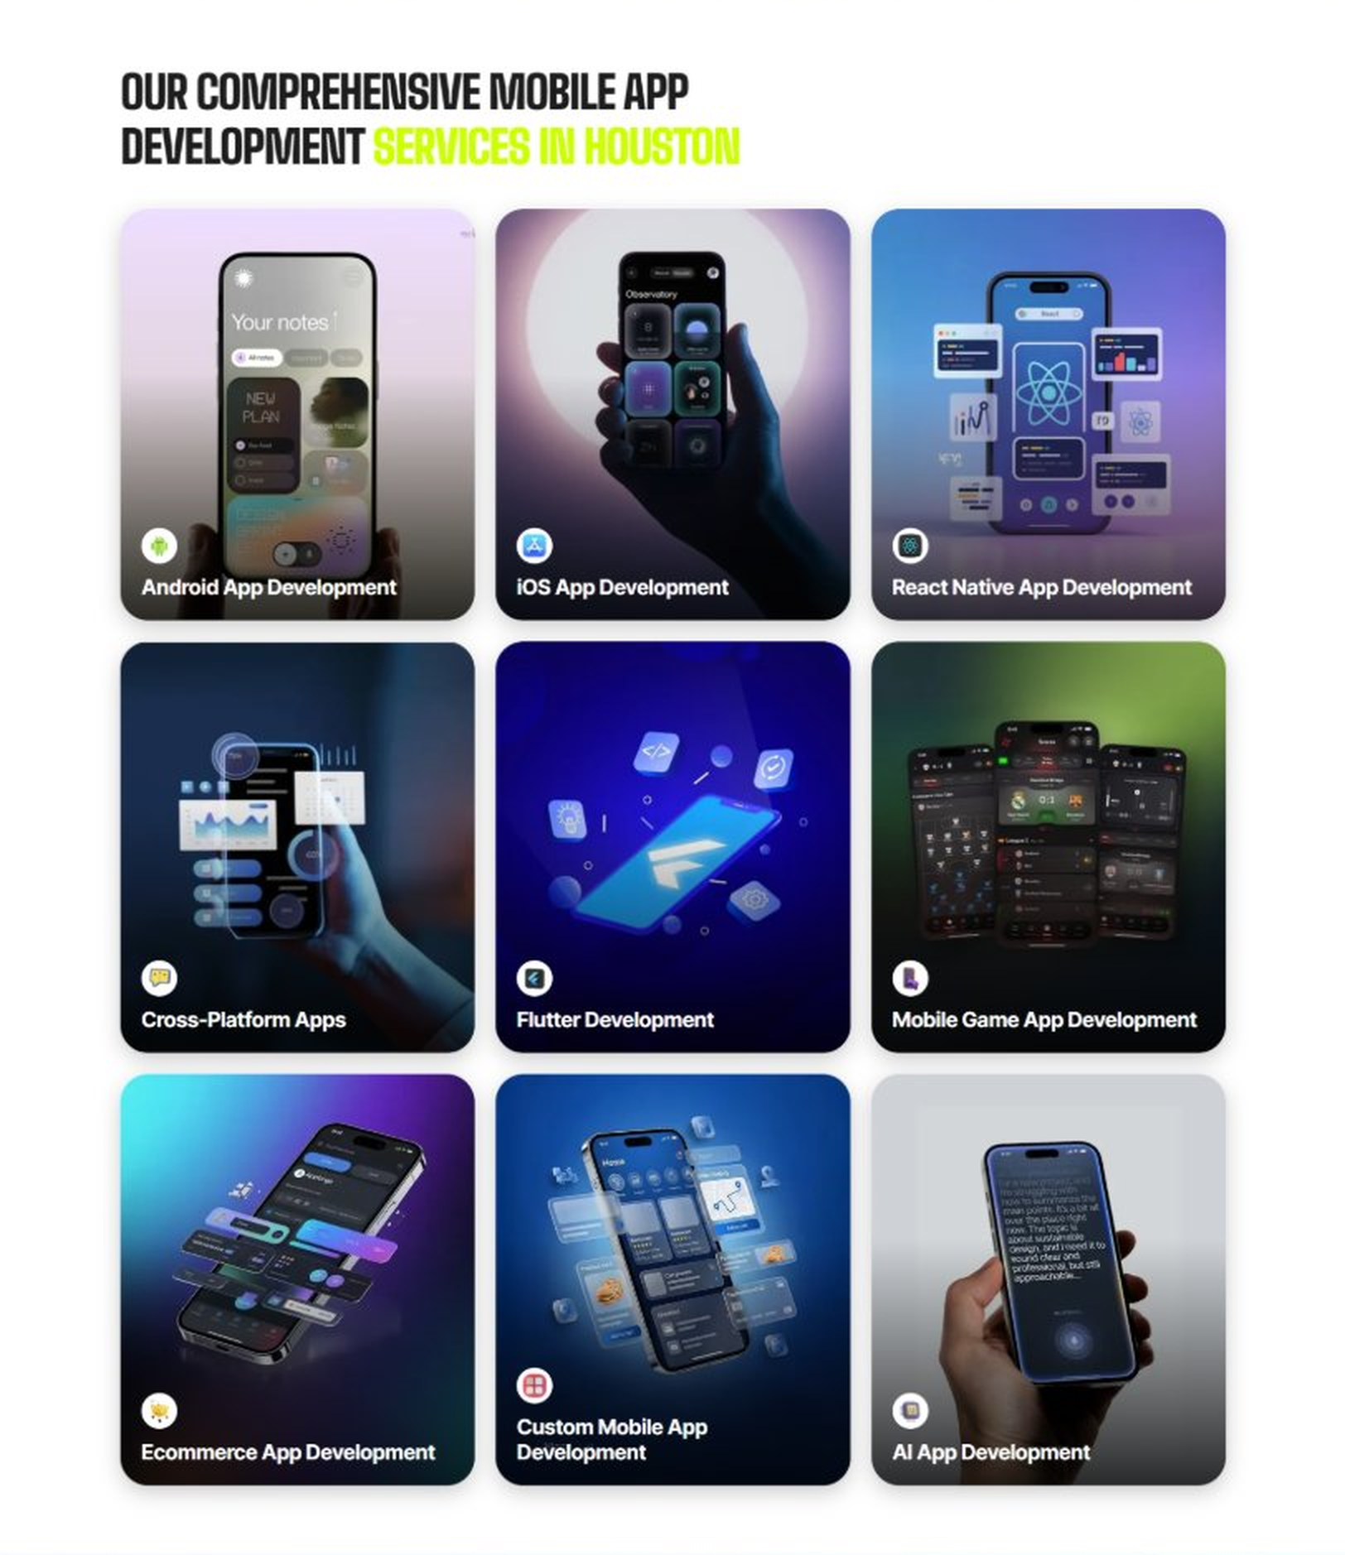
Current live page, www.appsters.io/industry
 | DETAIL
Status | New copy applied
Build Notes | Live grid holds 9 cards. New copy holds 5 services. Either trim the grid to 5 or brief four more services.
Copy For This Fold
PAGE ELEMENT | COPY (WORD FOR WORD)
H2 (Section Heading) | Taxi Application Development Services Built For Riders Who Expect Instant Pickups
Body Copy | Strong ride hailing platforms sit at the crossroads of matching, routing, and payment. As a taxi app development company, we connect operational thinking with technical precision, delivering custom ride hailing app development that fits how riders and drivers actually use their phones.
Service 1 Heading | Taxi Business
Service 1 Copy | As Taxi app developers, we build the core matching and dispatch engine that connects riders to the closest available driver in seconds, not minutes.
Service 2 Heading | Car Rental
Service 2 Copy | Our car rental app development work covers vehicle browsing, booking, and digital handoff, letting rental fleets run bookings without a counter line.
Service 3 Heading | Corporate Taxi
Service 3 Copy | We build corporate taxi apps that let businesses manage employee ride accounts, expense reporting, and approval workflows from one dashboard.
Service 4 Heading | Limousine Service
Service 4 Copy | Our limousine rental app works to handle scheduled bookings, chauffeur assignment, and premium service tracking for operators running a higher-end fleet.
Service 5 Heading | Chauffeurs App
Service 5 Copy | As a chauffeur app development company, we build driver-facing tools tuned for professional chauffeurs, from route planning to client preference tracking.
FOLD 6: Case Study CTA
Case Study CTA: HELPP
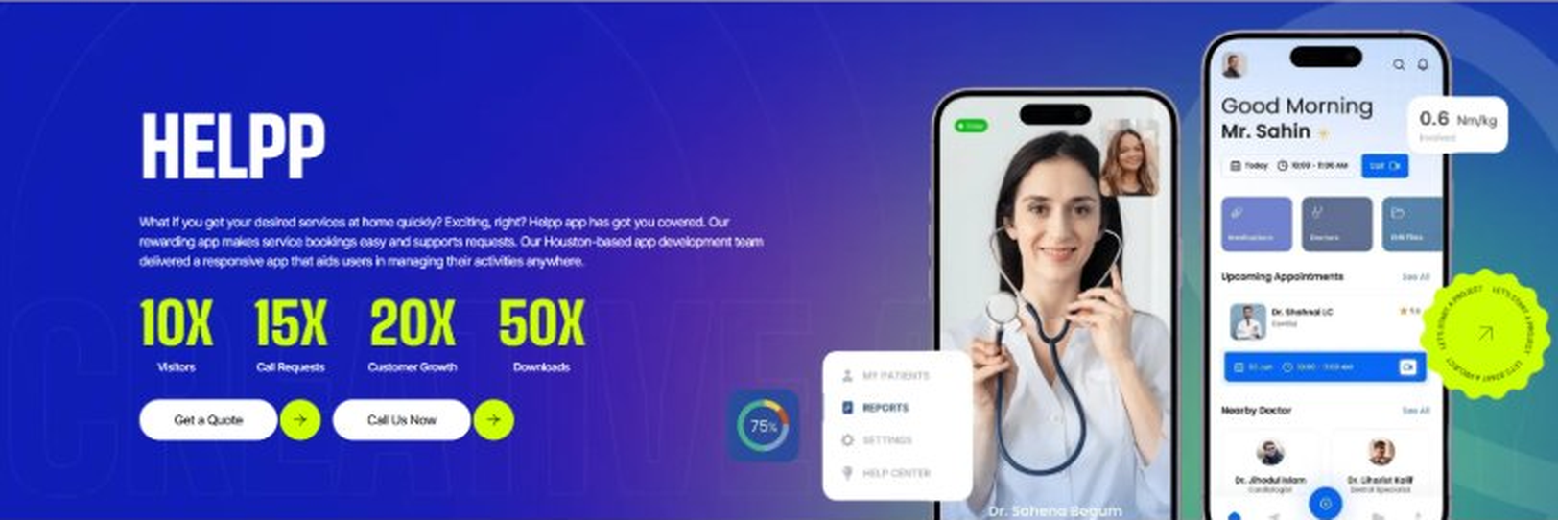
Current live page, www.appsters.io/industry
 | DETAIL
Status | New copy applied
Build Notes | Live block holds a product name, a paragraph, four metric counters and two CTA buttons. New copy supplies the heading and paragraph. Metrics still need to be supplied.
Copy For This Fold
PAGE ELEMENT | COPY (WORD FOR WORD)
H2 (Section Heading) | Taxi Booking App Developers Who Build For Reliability, Not Just Downloads
Body Copy | Launching a ride-hailing app is easy. Getting drivers and riders to actually trust it during rush hour is the hard part. If you're ready to develop taxi apps that compete with the platforms riders already know, Appsters is the partner that gets you there. Let's talk about your market and what a platform built to scale actually requires.
FOLD 7: Testimonials
Testimonials: Real Stories From People Who Wanted What’s Next
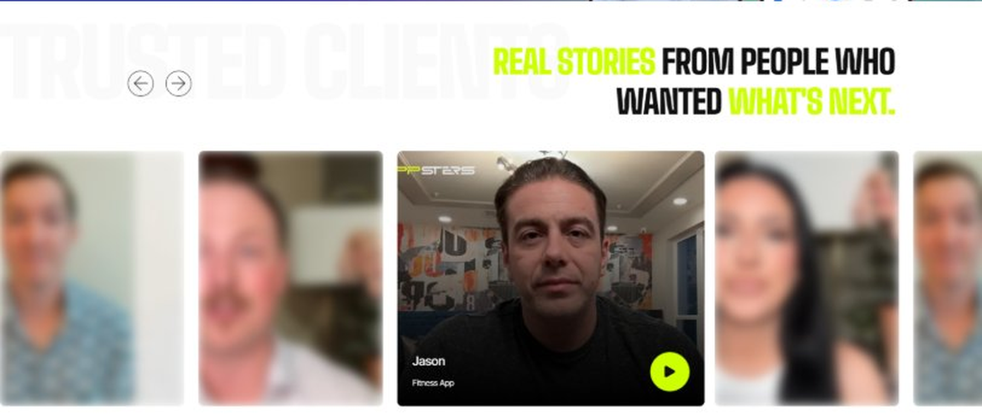
Current live page, www.appsters.io/industry
 | DETAIL
Status | New copy applied
Build Notes | Live block runs video testimonials. New copy is written quotes with attributions. Source document marks this fold design TBD.
Copy For This Fold
PAGE ELEMENT | COPY (WORD FOR WORD)
H2 (Section Heading) | What Our Clients Say
Testimonial 1 Quote | "We were losing drivers to bigger platforms before this launch. Better payout transparency and faster matching turned that around within two months, which honestly surprised even our own team."
Testimonial 1 Attribution | Hassan Idrissi, Founder
Testimonial 2 Quote | "I've run fleets for over a decade, and this is the first dispatch system that actually reduced idle driver time instead of just reporting on it after the fact."
Testimonial 2 Attribution | Teresa Lombard, Fleet Operations Director
Testimonial 3 Quote | "Airport pickups used to be our biggest source of complaints. The flight tracking integration alone solved most of it, and drivers stopped circling the terminal waiting on delayed passengers."
Testimonial 3 Attribution | Omar Farouk, Operations Manager
Testimonial 4 Quote | "Surge pricing is a sensitive topic with riders, and Appsters built a model that riders actually seem to accept as fair. That's harder to get right than it sounds."
Testimonial 4 Attribution | Claire Dunmore, Chief Product Officer
Testimonial 5 Quote | "What impressed me most was how the app performed during a city-wide event that spiked demand tenfold overnight. Nothing buckled, and that's when it matters most."
Testimonial 5 Attribution | Devon Ackerley, Chief Executive Officer
Source document note: Testimonial fold, design TBD after content
FOLD 8: Technology Logo Strip
Technology Logo Strip

Current live page, www.appsters.io/industry
 | DETAIL
Status | No copy change
Build Notes | No new copy in the source document for this fold. Keep the live block exactly as it is.
FOLD 9: Why Choose Us
Why Choose Us: Compelling Reasons To Choose Us As A Trustable App Development Company In Houston
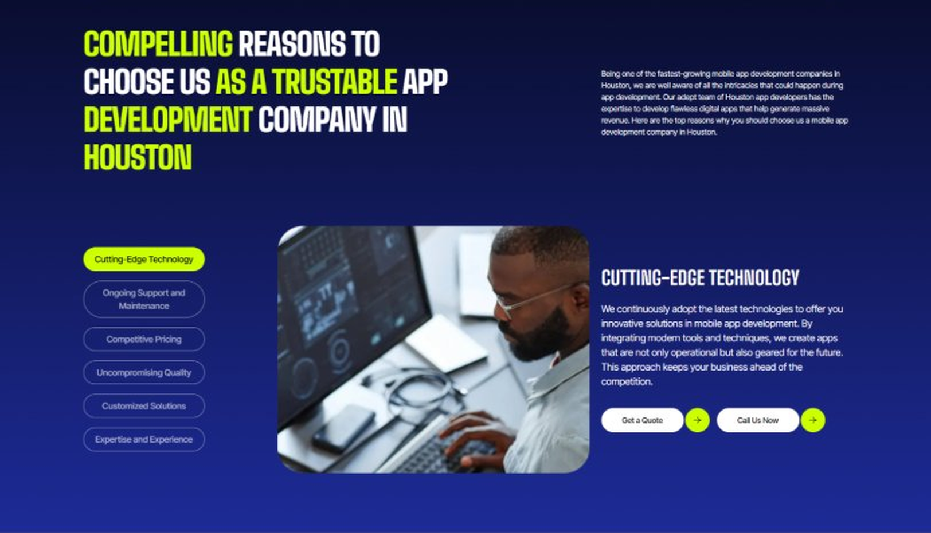
Current live page, www.appsters.io/industry
 | DETAIL
Status | New copy applied
Build Notes | Live block holds 6 tabs. New copy holds 6 reasons. Clean one to one fit, no design change needed.
Copy For This Fold
PAGE ELEMENT | COPY (WORD FOR WORD)
H2 (Section Heading) | Why Operators Choose Appsters As Their Trusted Taxi App Partner
Body Copy | Choosing a taxi app development partner shapes whether your platform can actually compete with the names riders already have installed. Our team blends operational thinking, engineering discipline, and matching expertise to build apps that win on reliability.
Reason 1 Heading | Match-Speed Architecture
Reason 1 Copy | We design every feature around getting a driver to a rider fast, backed by real dispatch data rather than assumptions.
Reason 2 Heading | Built-In Surge Logic
Reason 2 Copy | Dynamic pricing isn't bolted on later. Our systems balance rider fairness and driver incentive from the first pricing model.
Reason 3 Heading | Peak-Demand Engineering
Reason 3 Copy | Our architecture is stress-tested for rush hour and event-night surges, so a demand spike becomes a good problem, not an outage.
Reason 4 Heading | Driver-First Usability
Reason 4 Copy | From dispatch to payouts, we design driver-facing tools simple enough to use one-handed between rides.
Reason 5 Heading | Transparent Development Cycles
Reason 5 Copy | We follow sprint cadences with review checkpoints and shared roadmaps, so clients always know what's shipping and what's improving.
Reason 6 Heading | Long-Term Platform Thinking
Reason 6 Copy | We structure apps as ecosystems that evolve with new markets and regulatory changes, built for longevity rather than a single launch cycle.
FOLD 10: Sector Tabs
Sector Tabs: Serving 40+ Sectors With Mobile App Development In Houston
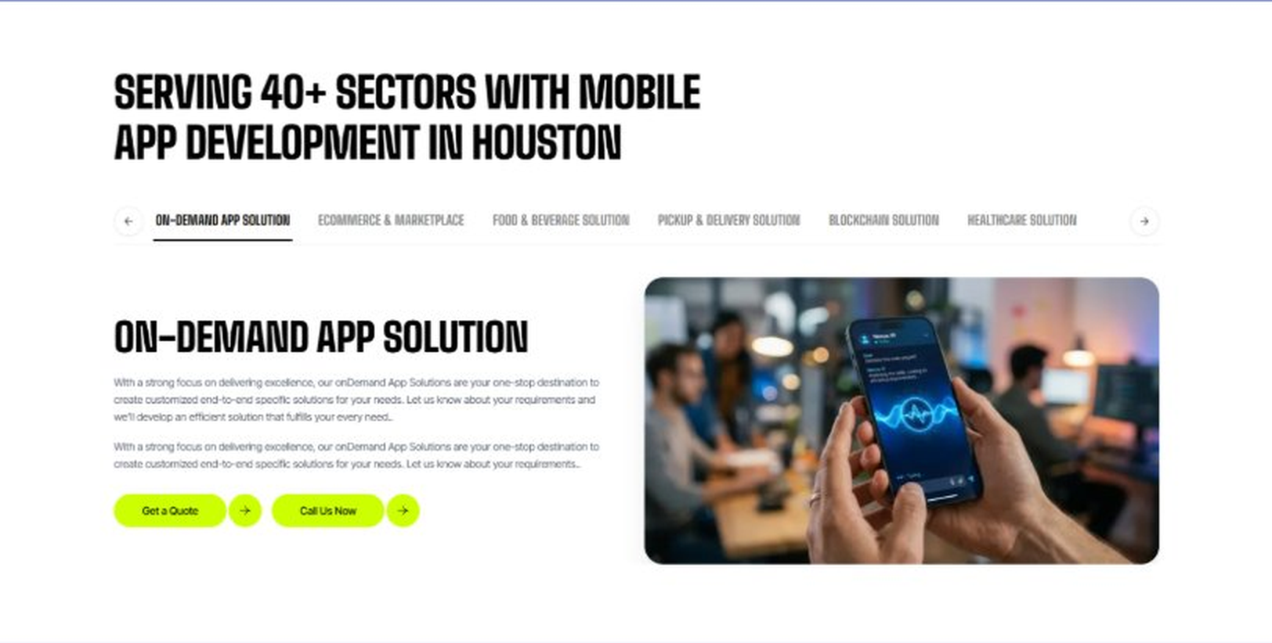
Current live page, www.appsters.io/industry
 | DETAIL
Status | New copy applied
Build Notes | Live block holds 6 sector tabs. New copy holds 5 solutions. Drop one tab or brief a sixth solution.
Copy For This Fold
PAGE ELEMENT | COPY (WORD FOR WORD)
H2 (Section Heading) | Taxi App Solutions Built For Every Part Of The Ride
Body Copy | Appsters delivers Taxi app development services that cover everything from dispatch to in-ride communication. Our systems are architected by senior taxi app developers who focus on match speed, accuracy, and stable performance across markets of every size.
Solution 1 Heading | Automated Driver & Fleet Management
Solution 1 Copy | Our fleet management tools automate driver assignment, shift scheduling, and vehicle maintenance tracking, cutting down on manual dispatch work.
Solution 2 Heading | Real-Time GPS Integration
Solution 2 Copy | Real-time GPS integration keeps rider and driver locations accurate to the second, so ETAs actually mean something.
Solution 3 Heading | AI Route Optimization
Solution 3 Copy | Our AI route optimization recalculates routes on the fly based on traffic and road conditions, cutting both ride time and fuel cost.
Solution 4 Heading | In-App Notifications & Communication
Solution 4 Copy | In-app notifications and communication tools keep riders and drivers connected without exchanging phone numbers, protecting privacy on both sides.
Solution 5 Heading | Airport Taxi App
Solution 5 Copy | Our airport taxi app features include flight tracking and designated pickup zone navigation, built specifically for the chaos of terminal pickups.
Solution 6 Heading | Carpool App
Solution 6 Copy | Our carpool app matching connects riders on similar routes, splitting fares fairly while keeping detours to a minimum.
Solution 7 Heading | Payment Gateway Integration
Solution 7 Copy | Secure payment gateway integration handles fares, tips, and driver payouts without third-party friction on either side.
FOLD 11: Engagement Models Table
Engagement Models Table: Flexible Engagement Models For Any App Development Need
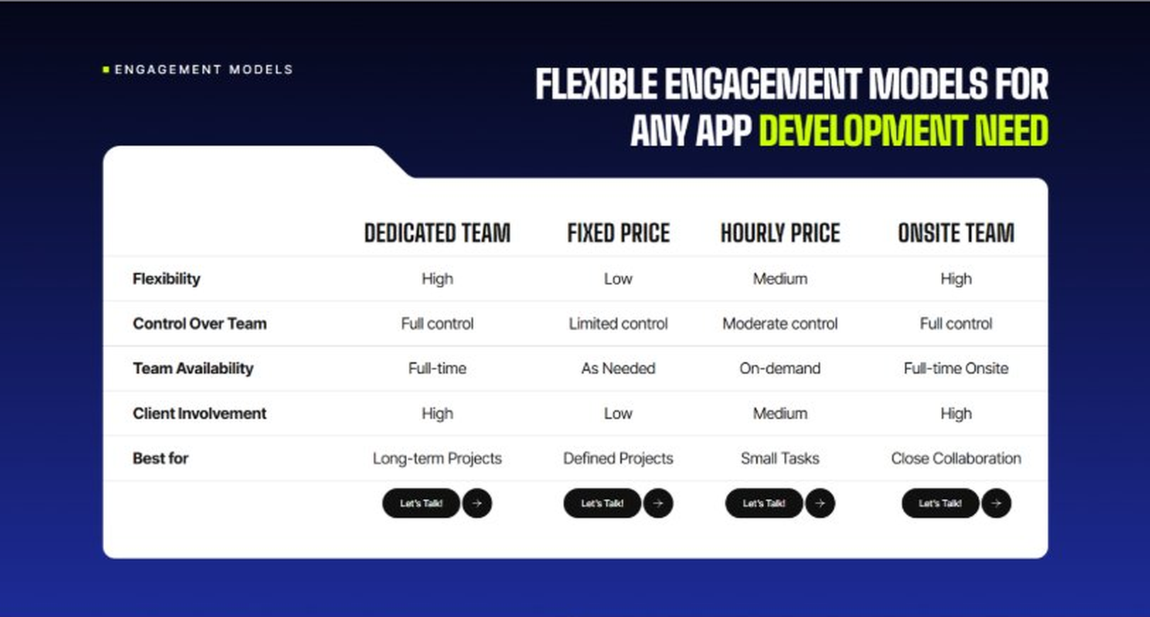
Current live page, www.appsters.io/industry
 | DETAIL
Status | No copy change
Build Notes | No new copy in the source document for this fold. Keep the live block exactly as it is.
FOLD 12: Game App CTA
Game App CTA: Into Engaging Mobile Games
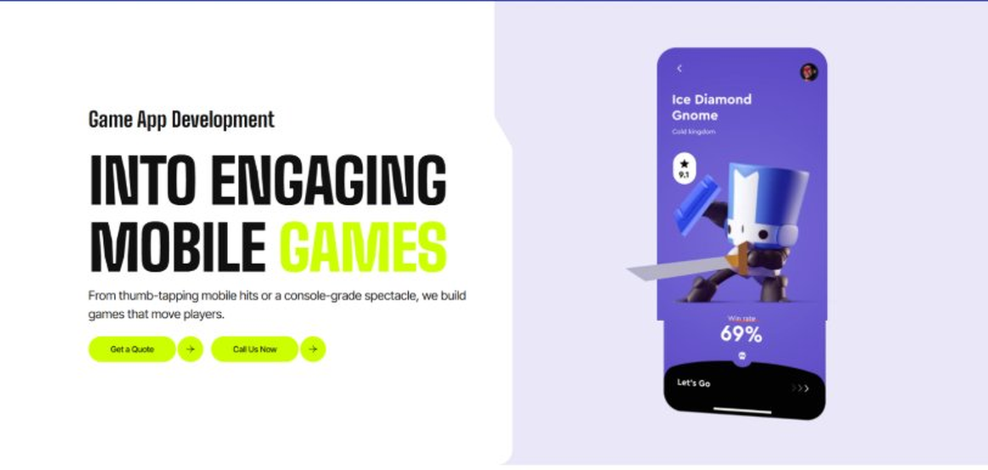
Current live page, www.appsters.io/industry
 | DETAIL
Status | No copy change
Build Notes | No new copy in the source document for this fold. Keep the live block exactly as it is.
FOLD 13: Collaboration And Client Logos
Collaboration And Client Logos
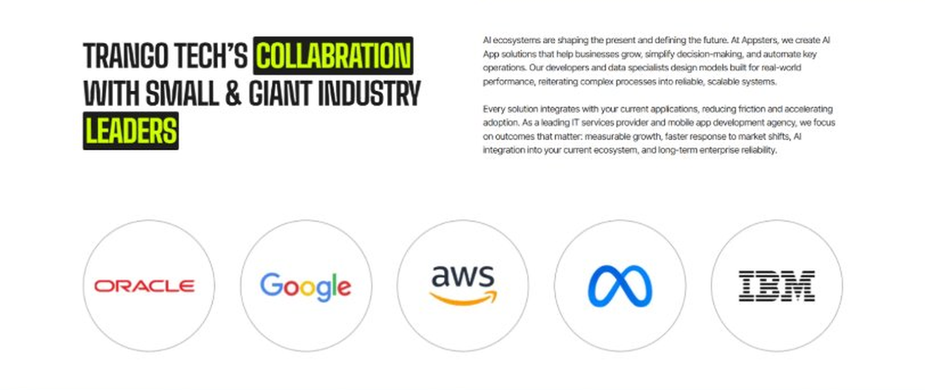
Current live page, www.appsters.io/industry
 | DETAIL
Status | No copy change
Build Notes | No new copy in the source document for this fold. Keep the live block exactly as it is.
QA Flag | Live heading reads "Trango Tech’s Collabration with Small & Giant Industry Leaders". That is a competitor name plus a spelling error sitting live on the page. Fix regardless of this content drop.
FOLD 14: Recognition CTA Banner
Recognition CTA Banner
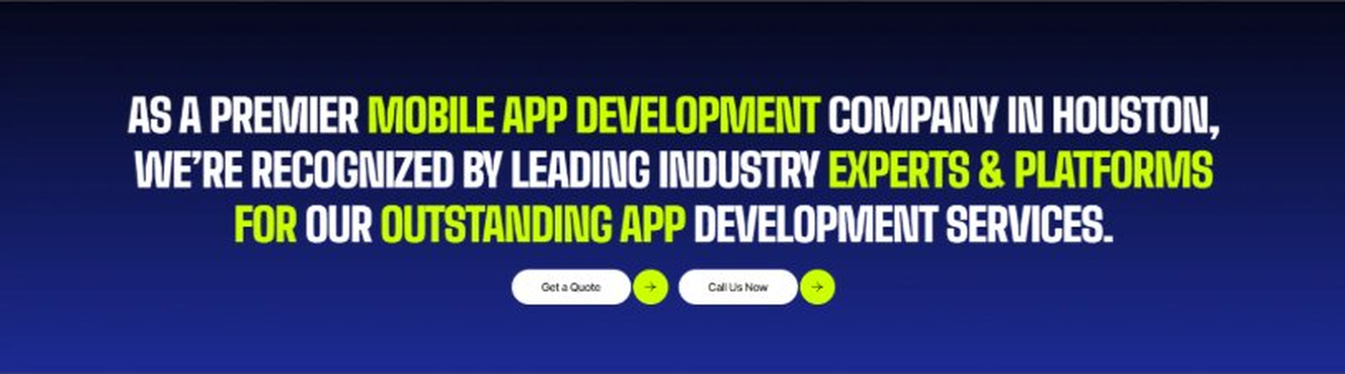
Current live page, www.appsters.io/industry
 | DETAIL
Status | New copy applied
Build Notes | Live block holds a headline and two CTA buttons. New copy supplies the heading and paragraph.
Copy For This Fold
PAGE ELEMENT | COPY (WORD FOR WORD)
H2 (Section Heading) | Someone's Requesting A Ride Right Now. Is Your Platform Ready To Match Them?
Body Copy | Every day you wait is a day another platform gets ahead on match speed and driver loyalty. Let's build a Taxi app that gets riders picked up fast and keeps drivers earning. Talk to Appsters today, and let's figure out what your first release actually needs to look like.
FOLD 15: Market Presence And Office Map
Market Presence And Office Map: Expand Your Market Presence
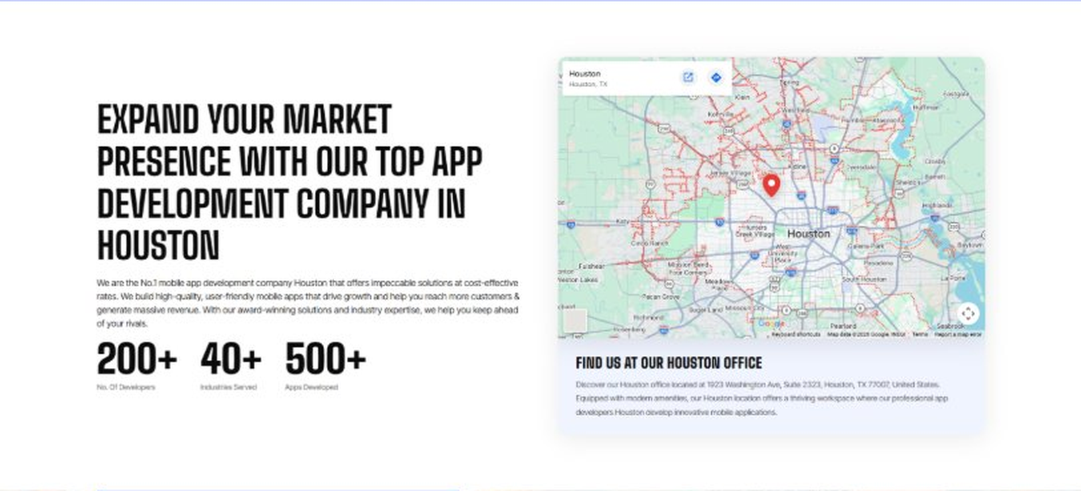
Current live page, www.appsters.io/industry
 | DETAIL
Status | New copy applied
Build Notes | Live block holds a heading, a paragraph, three counters and the office map. New copy supplies the heading and paragraph.
Copy For This Fold
PAGE ELEMENT | COPY (WORD FOR WORD)
H2 (Section Heading) | Taxi Booking App Development Company Expertise Behind Every Ride-Hailing Platform We Build
Body Copy | As a team that knows how to develop mobile taxi apps at scale, we bring deep experience across matching algorithms, payment processing, and driver operations. Our engineers have shipped ride-hailing platforms handling thousands of concurrent trips, giving us a deeper bench than studios building their first dispatch system. React Native, Swift, Kotlin, Node.js, and real-time geolocation APIs form our core stack, paired with AI models tuned for demand prediction, surge pricing, and fraud detection. Where most competitors treat matching as a simple radius search, we build it as a continuously optimized system.
FOLD 16: Portfolio
Portfolio: Quick Glimpse On Our Portfolio

Current live page, www.appsters.io/industry
 | DETAIL
Status | New copy applied
Build Notes | Live block holds a heading, a paragraph and one CTA. New copy holds an intro plus 4 named product cards. Source document marks this fold design TBD.
Copy For This Fold
PAGE ELEMENT | COPY (WORD FOR WORD)
H2 (Section Heading) | Taxi Products Engineered For Faster Matches And Fairer Rides
Body Copy | Appsters builds ride-hailing platforms that behave like long-term infrastructure, not a one-city pilot. Our solutions stand out because they blend matching algorithms, payment logic, and driver behavior analytics in one stable system. Every product is architected for speed, fairness, and real reliability.
Product 1 Heading | RideNow
Product 1 Copy | RideNow is a ride-hailing app built for mid-size cities that major platforms have underserved. Fast matching, transparent pricing, and driver incentive tools helped it reach profitability faster than the founders expected.
Product 2 Heading | FleetCommand
Product 2 Copy | FleetCommand is a fleet management app that gives taxi operators real-time visibility into every vehicle, driver, and fare, replacing radio dispatch with something far more precise.
Product 3 Heading | AirportGo
Product 3 Copy | AirportGo is an airport transfer app with flight tracking built in, automatically adjusting pickup times when a flight runs late instead of leaving drivers waiting or riders stranded.
Product 4 Heading | CarpoolConnect
Product 4 Copy | CarpoolConnect is a shared ride app that matches riders heading the same direction, cutting costs for passengers and increasing per-trip revenue for drivers.
Source document note: Portfolio fold, design TBD after content
FOLD 17: Tech Stack Tabs
Tech Stack Tabs: Mobile App Development, A Tech Stack For The Bold
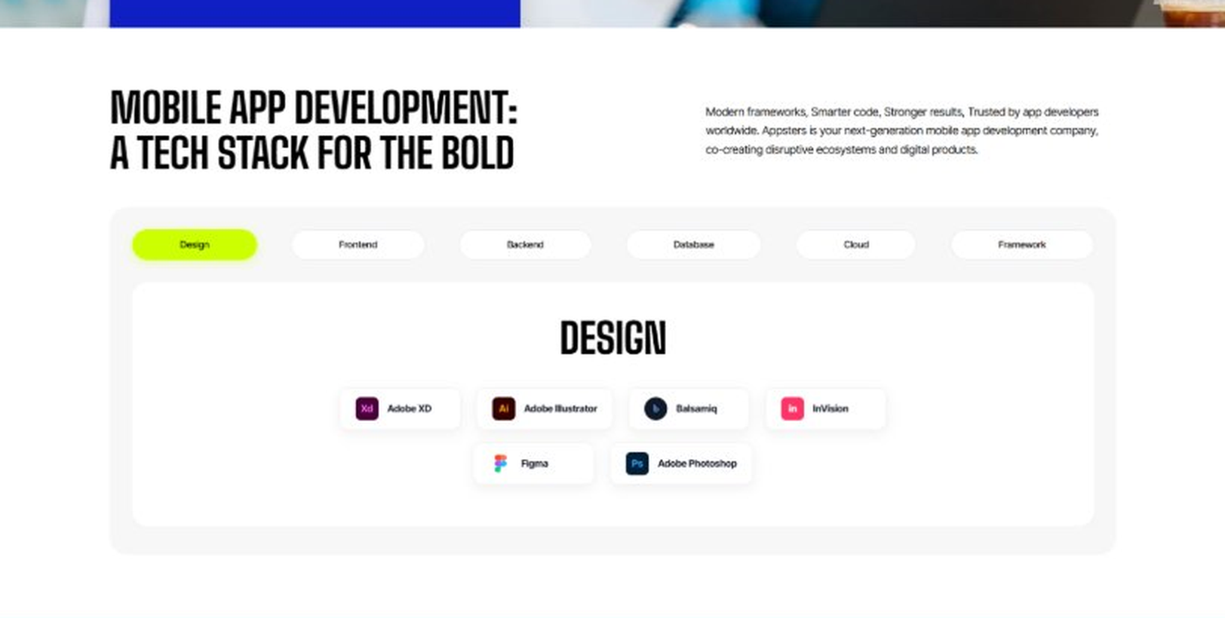
Current live page, www.appsters.io/industry
 | DETAIL
Status | New copy applied
Build Notes | Live block holds 6 category tabs with tool logos. New copy supplies the heading and paragraph, the tab contents stay as they are.
Copy For This Fold
PAGE ELEMENT | COPY (WORD FOR WORD)
H2 (Section Heading) | Technology Stack That Powers High-Performance Taxi Applications
Body Copy | Our engineering foundation supports live GPS tracking, real-time matching, and platform-wide scalability. Through our Taxi application development services, we use Swift, Kotlin, Flutter, React Native, Node.js, real-time geolocation APIs, and secure cloud infrastructure alongside AI-driven demand prediction engines. Every stack decision reinforces speed, accuracy, and long-term flexibility so your platform can grow without a rebuild.
FOLD 18: Process
Process: App Development Process
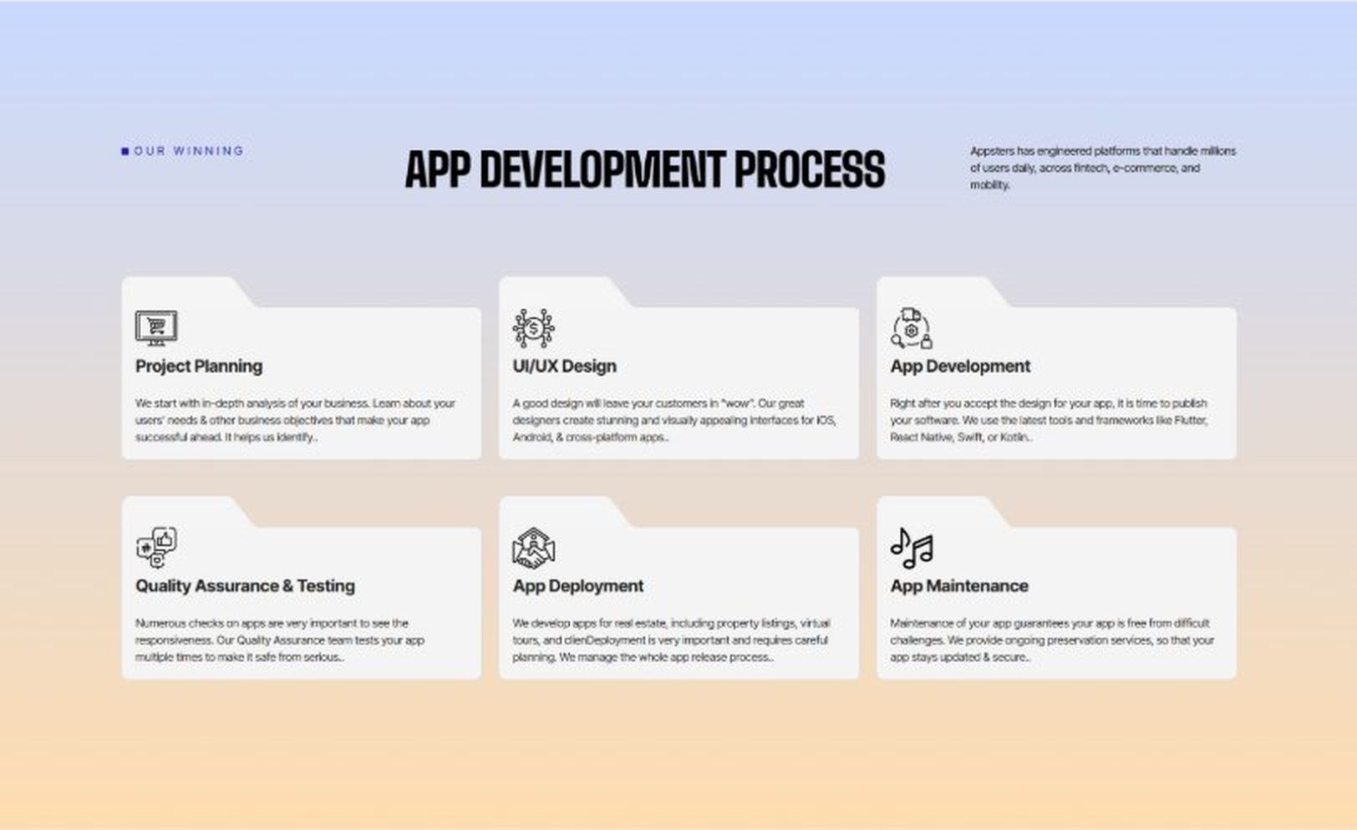
Current live page, www.appsters.io/industry
 | DETAIL
Status | New copy applied
Build Notes | Live block holds 6 step cards. New copy holds 8 steps. Either widen the block to 8 or merge two steps.
Copy For This Fold
PAGE ELEMENT | COPY (WORD FOR WORD)
H2 (Section Heading) | Ride Hailing App Development Process Built For Platforms That Scale Fast
Body Copy | A ride hailing platform needs more than a map and a button. It needs structure, clarity, and a process engineered for speed, safety, and scale from day one. Our process aligns product goals with technical roadmaps so every phase moves with intention.
Step 1 Heading | App Idea & Research
Step 1 Copy | Every project begins with structured discovery, where our teams map local market dynamics, driver supply, and rider expectations. We benchmark existing ride-hailing platforms and define what will actually win drivers and riders in your market. By the time research closes, the product's purpose, risks, and growth path are already clear.
Step 2 Heading | Strategic Planning & Consultation
Step 2 Copy | Here we translate research into a measurable plan. Our strategists define the technical architecture, pricing logic, and delivery milestones needed to build your AI taxi mobile app the right way, from the first sprint.
Step 3 Heading | Wireframing & Prototyping
Step 3 Copy | We turn ideas into tangible user journeys. Wireframes capture rider booking flows, driver dispatch screens, and in-ride communication in a visual structure stakeholders can react to before a single line of code gets written.
Step 4 Heading | App Development
Step 4 Copy | This is where engineering takes over. Our developers implement matching algorithms, GPS tracking, and payment systems with the same discipline a chauffeur app development company applies to punctuality and service quality. Development stays sprint-driven and transparent throughout.
Step 5 Heading | Expert QA & Testing
Step 5 Copy | Quality assurance covers far more than bug hunting. We validate GPS accuracy, matching logic under real demand conditions, and payment reliability. Only stable, predictable behavior earns approval to move forward.
Step 6 Heading | App Launch
Step 6 Copy | Launch is a coordinated rollout, not a leap of faith. We manage store compliance, driver onboarding flow, and final performance checks so your platform enters the market ready to hold real ride volume.
Step 7 Heading | Deployment
Step 7 Copy | Our deployment pipelines are built for consistency and safety. We configure cloud infrastructure, optimize for real-time GPS data at scale, and calibrate autoscaling so your app performs the same for 100 drivers as it does for 10,000.
Step 8 Heading | Maintenance & Support
Step 8 Copy | Post-launch, we keep monitoring matching accuracy, refining pricing logic, patching vulnerabilities, and responding to new regulatory or app store requirements, so your platform keeps improving long after day one.
Source document note: Process fold, design TBD after content
FOLD 19: Blog Posts
Blog Posts: Our Related Blog Posts
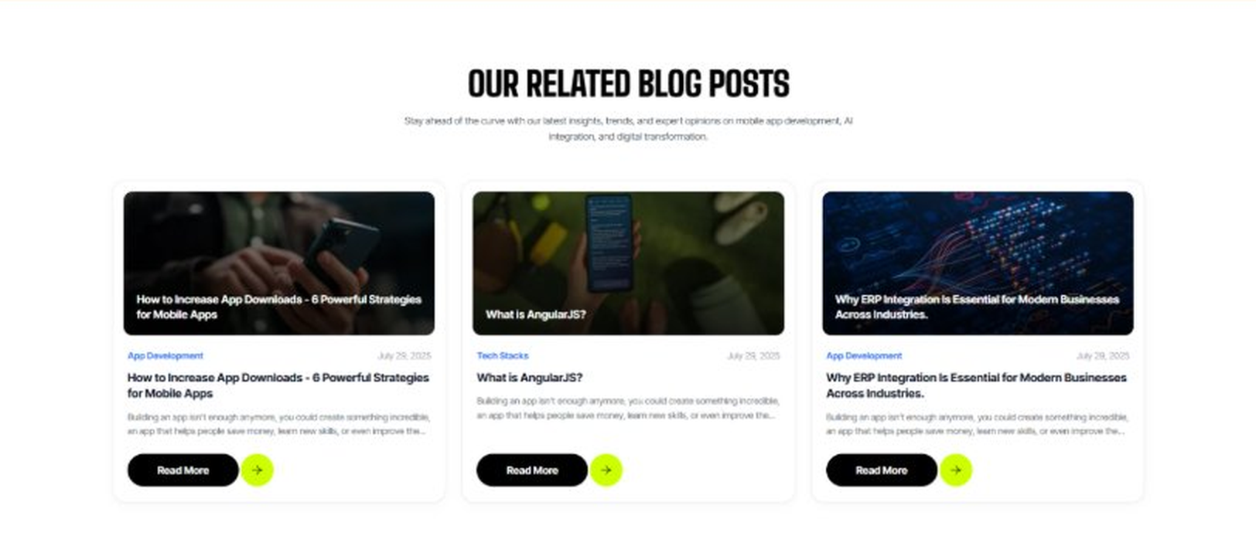
Current live page, www.appsters.io/industry
 | DETAIL
Status | No copy change
Build Notes | No new copy in the source document for this fold. Keep the live block exactly as it is.
FOLD 20: FAQs
FAQs: Your Questions, Our Clarity
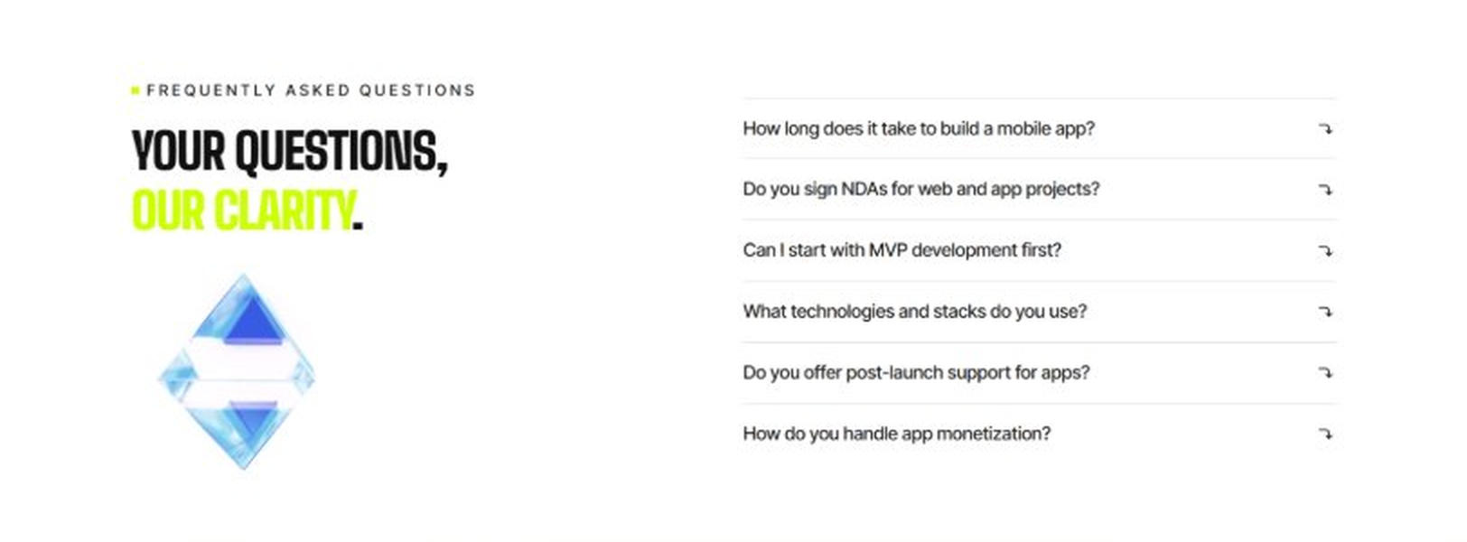
Current live page, www.appsters.io/industry
 | DETAIL
Status | New copy applied
Build Notes | Live block holds 6 accordion rows. New copy holds 6 questions and answers. Clean one to one fit.
Copy For This Fold
PAGE ELEMENT | COPY (WORD FOR WORD)
H2 (Section Heading) | Frequently Asked Questions
FAQ 1 Question | How long does it typically take to build a fully functional taxi app?
FAQ 1 Answer | Timelines depend on market complexity, payment integrations, and fleet size. Most projects take 12 to 20 weeks for a stable release, including design, engineering, QA, and pilot testing. As a taxi app development company, we provide clear milestones from day one.
FAQ 2 Question | Can Appsters build an AI taxi app with smart matching?
FAQ 2 Answer | Yes. We build AI taxi apps with demand prediction, dynamic pricing, and automated dispatch baked into the core architecture, not added as an afterthought.
FAQ 3 Question | Is Appsters a ride hailing app development company that handles regulatory compliance across markets?
FAQ 3 Answer | Yes. As a ride hailing app development company operating across multiple regions, we build compliance checks for licensing, insurance, and local regulations directly into the platform.
FAQ 4 Question | What makes Appsters different from other taxi mobile app development company options?
FAQ 4 Answer | We treat match speed, driver retention, and pricing fairness as core product decisions, not add-ons. Most taxi app development companies focus on UI first and matching logic later. We do both from the start.
FAQ 5 Question | Can you handle sudden demand spikes during events or rush hour?
FAQ 5 Answer | Yes. Our architecture is stress-tested for exactly this kind of load, so a demand spike becomes a growth moment instead of a downtime incident.
FAQ 6 Question | What ongoing support does a chauffeur app development firm like Appsters provide after launch?
FAQ 6 Answer | Our support includes post-launch monitoring, feature updates, compliance checks, and infrastructure scaling, so your platform keeps improving long after release.
FOLD 21: Locations
Locations: Our Global Presence
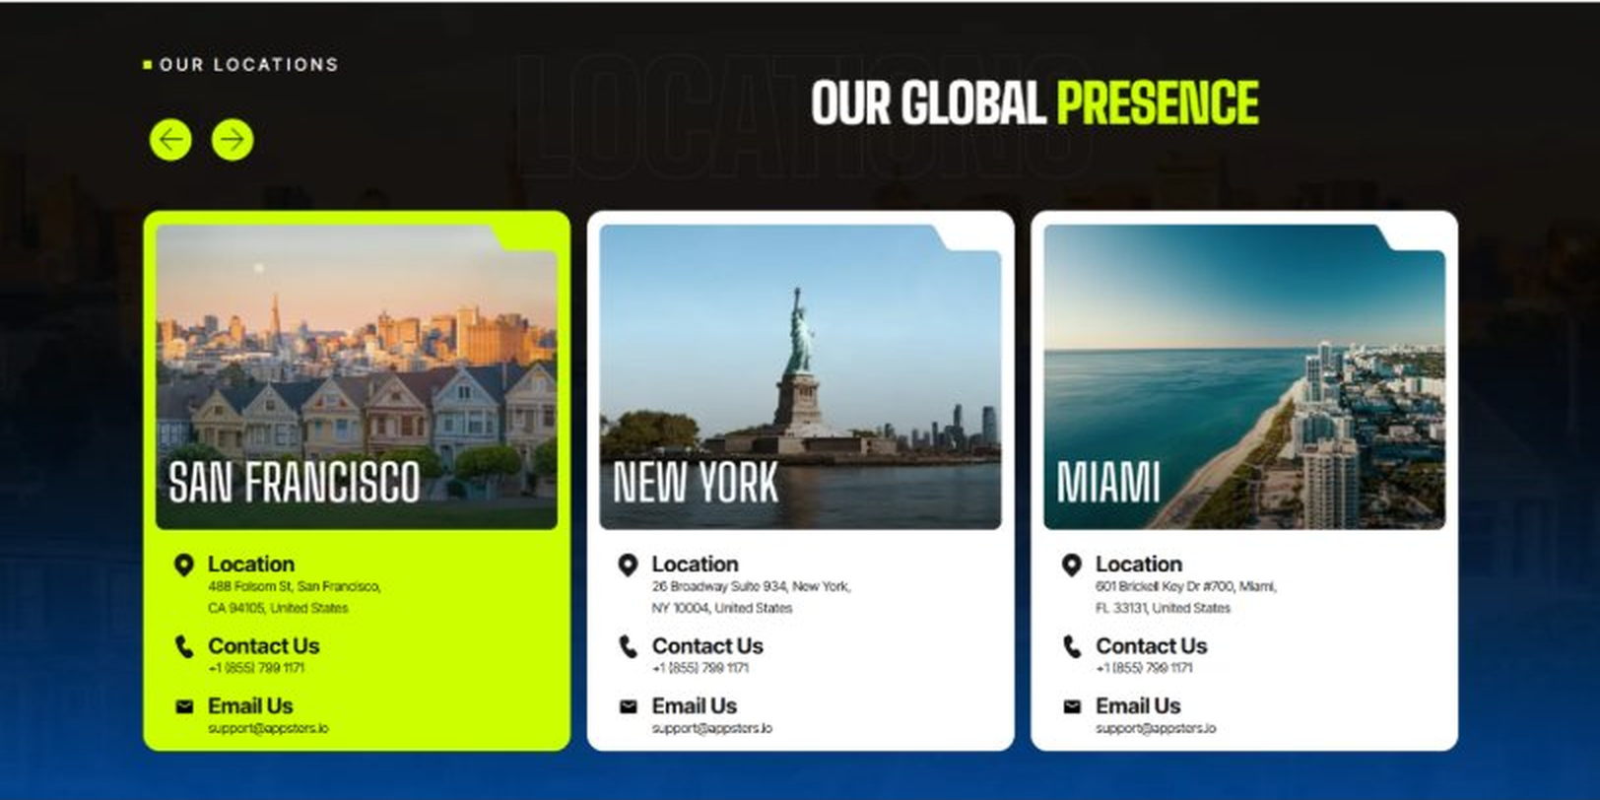
Current live page, www.appsters.io/industry
 | DETAIL
Status | No copy change
Build Notes | No new copy in the source document for this fold. Keep the live block exactly as it is.
FOLD 22: Contact Form
Contact Form: Connect With Us
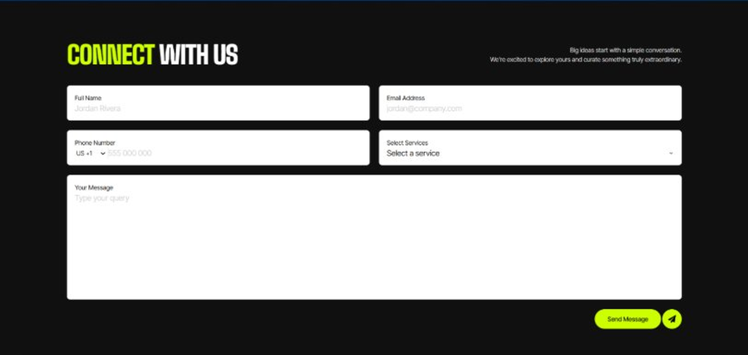
Current live page, www.appsters.io/industry
 | DETAIL
Status | No copy change
Build Notes | No new copy in the source document for this fold. Keep the live block exactly as it is.
FOLD 23: Footer
Footer
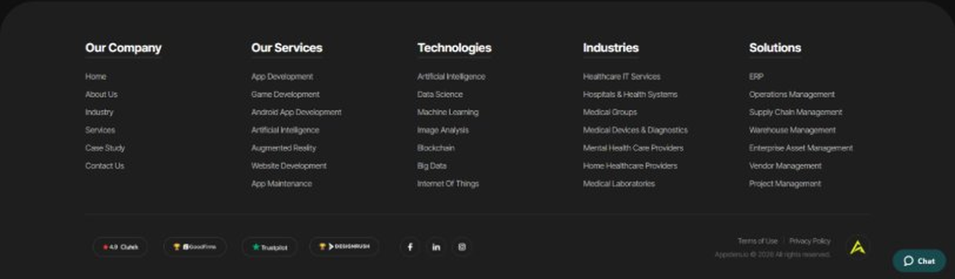
Current live page, www.appsters.io/industry
 | DETAIL
Status | No copy change
Build Notes | No new copy in the source document for this fold. Keep the live block exactly as it is.
NEW BLOCKS REQUIRED
The three blocks below are in the source content but have no matching section anywhere on the current /industry page. Each one needs a new block built.
NEW BLOCK: Building Ride Hailing Apps Better Than The Industry Giants
 | DETAIL
Status | No equivalent block on the live page
Placement | Suggested placement: directly after Fold 5, reusing the services card grid styling.
Copy For This Block
PAGE ELEMENT | COPY (WORD FOR WORD)
H2 (Section Heading) | Building Ride Hailing Apps Better Than The Industry Giants
Body Copy | Ride hailing platforms shaped how an entire generation gets around. Our role is to build the next version of that experience, sharper, fairer, and better suited to the markets the giants have underserved.
Feature 1 Heading | Apps Like Uber
Feature 1 Copy | We build ride-hailing platforms inspired by Uber but tuned for markets it hasn't optimized for, with better driver incentive structures and pricing that feels fair on both sides.
Feature 2 Heading | Apps Like Bolt
Feature 2 Copy | We create lightweight, fast-matching apps in the spirit of Bolt, built for cities where speed and low fees matter more than a long feature list.
Feature 3 Heading | Apps Like Waymo
Feature 3 Copy | We build autonomous-ready dispatch architecture inspired by Waymo's approach, positioning fleet operators to integrate autonomous vehicles as the technology matures.
Feature 4 Heading | Apps Like Lyft
Feature 4 Copy | We design rider-friendly platforms with the community feel Lyft built its reputation on, adding stronger loyalty tools and driver transparency.
Feature 5 Heading | Apps Like Careem
Feature 5 Copy | We build super-app style platforms inspired by Careem, extending ride hailing into deliveries and payments within a single, unified rider experience.
NEW BLOCK: Industries We Serve
 | DETAIL
Status | No equivalent block on the live page
Placement | Suggested placement: directly after Fold 10, as a card grid rather than tabs.
Copy For This Block
PAGE ELEMENT | COPY (WORD FOR WORD)
H2 (Section Heading) | Industries We Serve
Body Copy | One Codebase. Infinite Industries. Our web, app, and AI solutions are built to perform, scale, and adapt while setting industry standards and redefining what's possible for businesses everywhere.
Industry 1 Heading | Fintech
Industry 1 Copy | We co-create secure, compliant fintech apps that simplify payments, investments, and trading, using the same transaction infrastructure we build for fares and driver payouts.
Industry 2 Heading | Healthcare
Industry 2 Copy | We develop HIPAA-compliant healthcare apps that bridge doctors, patients, and data, applying the same real-time dispatch logic we use for non-emergency medical transport.
Industry 3 Heading | Education
Industry 3 Copy | Our education apps gamify learning and power virtual classrooms, borrowing the same real-time notification systems we use to keep riders and drivers in sync.
Industry 4 Heading | Real Estate
Industry 4 Copy | We design real estate apps that help buyers, sellers, and agents close deals faster, using the same geolocation infrastructure we build for ride matching.
Industry 5 Heading | Automotive
Industry 5 Copy | From fleet dashboards to car rental apps, we digitize automotive operations using the same telematics expertise behind our taxi fleet platforms.
Industry 6 Heading | Music
Industry 6 Copy | We create streaming apps and artist marketplaces, applying the same real-time infrastructure that keeps ride requests matching instantly.
Industry 7 Heading | Social Media
Industry 7 Copy | We build social platforms that are scalable and sticky, drawing on the same high-availability infrastructure that keeps our taxi apps running during peak demand.
Industry 8 Heading | Logistics
Industry 8 Copy | We power logistics apps with route optimization and real-time tracking, using the same dispatch engine expertise behind our taxi platforms.
Industry 9 Heading | Ecommerce
Industry 9 Copy | We build ecommerce apps with frictionless checkouts and AI product recommendations, backed by the same payment infrastructure we use across our ride-hailing platforms.
NEW BLOCK: Advanced Technologies That Power Our Taxi Apps
 | DETAIL
Status | No equivalent block on the live page
Placement | Suggested placement: directly after Fold 17, reusing the services card grid styling.
Copy For This Block
PAGE ELEMENT | COPY (WORD FOR WORD)
H2 (Section Heading) | Advanced Technologies That Power Our Taxi Apps
Body Copy | As a taxi app development company built around what's next, we don't stop at matching and maps. Every taxi app developer on our team stays current with tools that keep platforms competitive, from AI demand prediction to live commerce. Unlike most taxi app development companies still relying on basic radius-based matching, we're already building AI-based taxi apps with these capabilities baked in.
Technology 1 Heading | AI Integrated Taxi Apps
Technology 1 Copy | We build AI-integrated taxi apps with demand prediction, dynamic surge modeling, and automated dispatch optimization, keeping wait times low even during unpredictable demand.
Technology 2 Heading | Wearable Integration
Technology 2 Copy | Our wearable integration lets drivers get dispatch alerts and navigation cues without constantly checking a phone mounted on the dash.
Technology 3 Heading | Cloud Solutions
Technology 3 Copy | Our cloud solutions keep location-heavy platforms fast and reliable, with autoscaling infrastructure built to absorb rush hour and event-driven spikes.
Technology 4 Heading | MVP For Taxi Apps
Technology 4 Copy | When you need to validate an idea fast, our MVP for Taxi Apps approach gets a functional, testable product into riders' hands without a twelve-month build cycle.
Technology 5 Heading | API Integration
Technology 5 Copy | We connect your platform to mapping services, payment processors, and other mobility ecosystems through clean, well-documented API integration.

